User Manual

Year: 2022 Semester: Spring Team: 8 Project: Gimbal Vehicle

Creation Date: 4/10/2022 Last Modified: 4/15/2022

Author: Deyuan Sun & team 8 Email: sun829@purdue.edu

Assignment Evaluation:

|  |  |  |  |  |
| --- | --- | --- | --- | --- |
| **Item** | **Score (0-5)** | **Weight** | **Points** | **Notes** |
| **Assignment-Specific Items** | | | | |
| **Product Description** |  | x1 |  |  |
| **Product Illustration** |  | x2 |  |  |
| **Setup Instructions** |  | x3 |  |  |
| **Usage Instructions** |  | x3 |  |  |
| **Troubleshooting Instructions** |  | x3 |  |  |
| **Writing-Specific Items** | | | | |
| **Spelling and Grammar** |  | x2 |  |  |
| **Formatting and Citations** |  | x1 |  |  |
| **Figures and Graphs** |  | x2 |  |  |
| **Technical Writing Style** |  | x3 |  |  |
| **Total Score** |  | | |  |

5: Excellent 4: Good 3: Acceptable 2: Poor 1: Very Poor 0: Not attempted

Comments:

*Comments from the grader will be inserted here.*

1. Product Description

This is a gimbal vehicle infrastructure. This vehicle is capable of omnidirectional moving by using omni wheels (mecanum or other wheel can achieve the function). This vehicle’s gimbal is capable to maintain a horizontal and vertical stable regardless of the status of chassis. We can manually set the direction that the gimbal is facing or let it faces to a default direction. Also, users can monitor IMU parameters of the vehicle in real time from the LCD screen on the controller. Other users are capable to add more functionality to our infrastructure. I.e., adding water gun to become a fire extinguisher, adding a camera to become a video recorder.

1. Product Illustrations

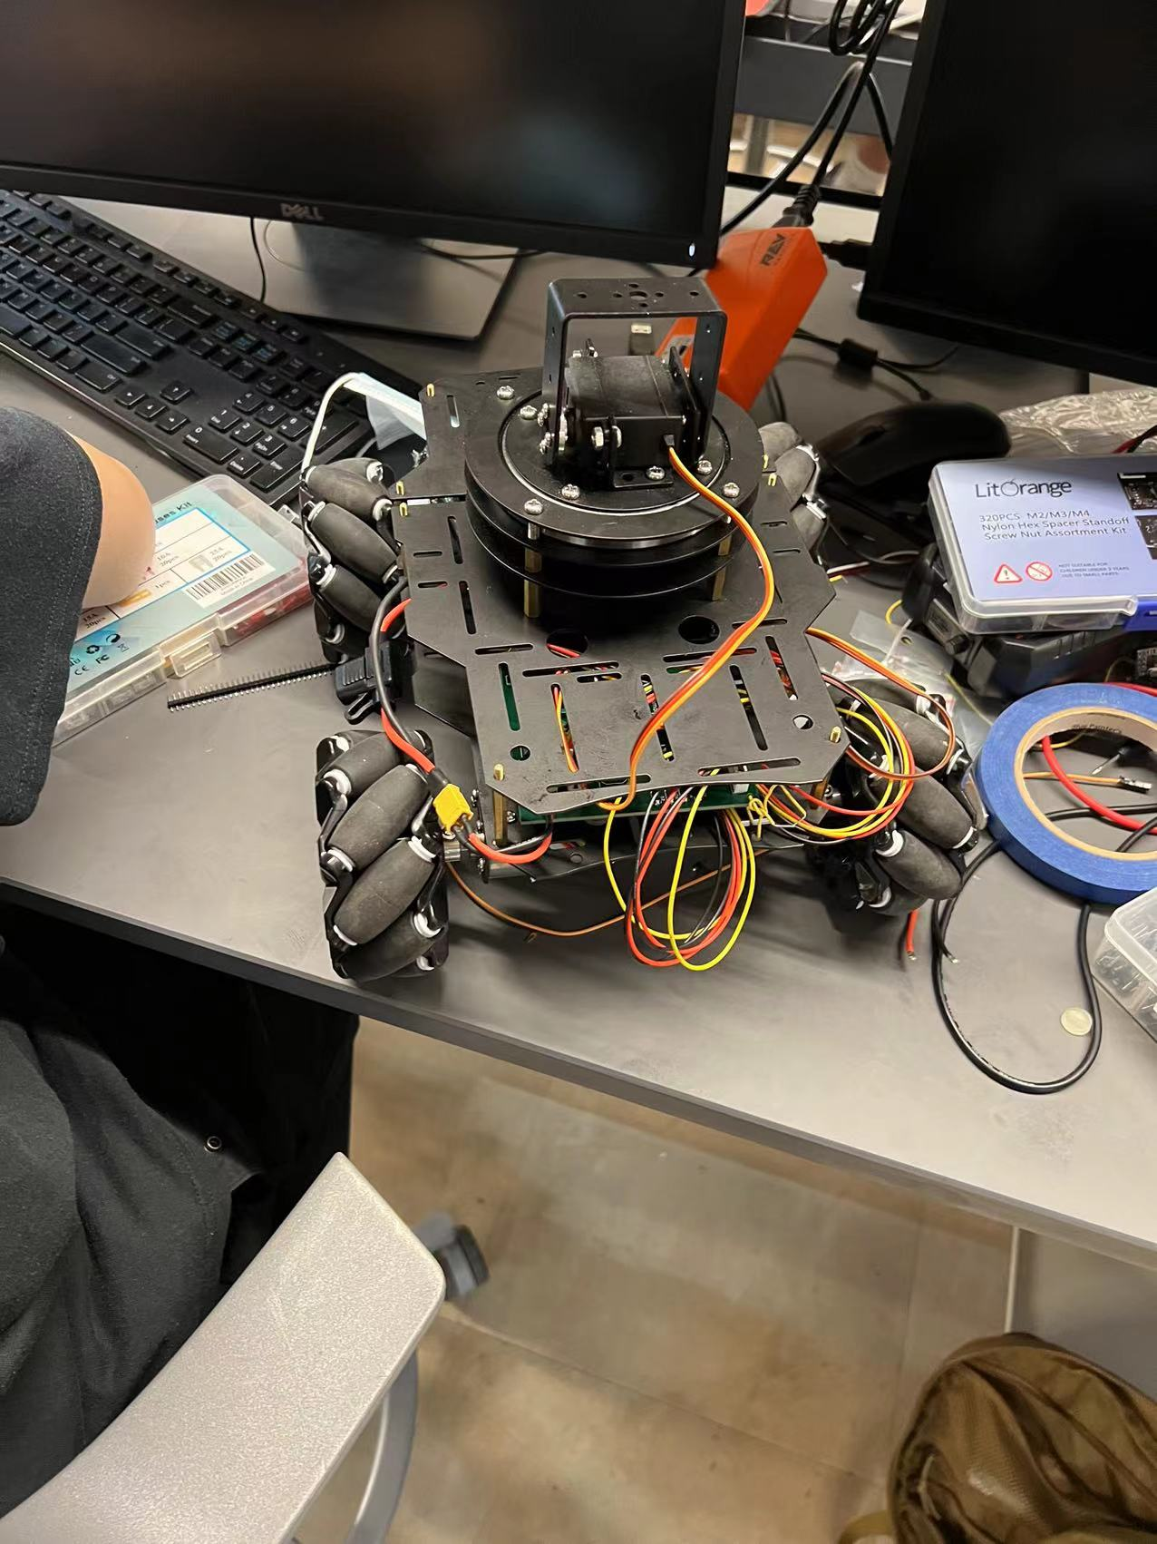

The overall chassis and the general gimbal part of the vehicle. 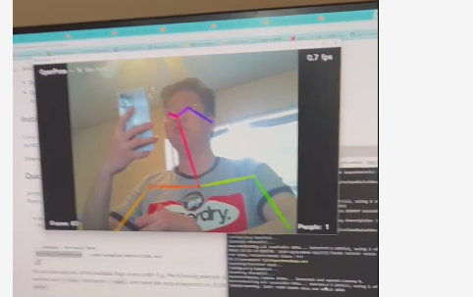

The feature to detect a human using open-source software – OPENPOSE

1. Setup Instructions

One good thing is that using this project do not require any extra set up. Everything is rather self-explanatory. Turn on the switches on the controller and on the gimbal vehicle, the user shall be ready to use. However, since we promise to make this a infrastructure. We have put every code on Github for more students and researchers to use, so that they can do their own modification and mode switch.

4.0 Usage Instructions

The user will need to choose from three modes, manual control mode, self-stabilizing mode, and stiff mode.

There is different feature available under 3 modes.

Manual control mode:

We are allowed to control the chassis using the left joystick, x1 and y1. Also, we are allowed to control the gimbal using the right side joystick.

Self stabilized mode:

We are allowed to control the chassis using left joystick just like previous mode. However, the gimbal itself will stay in the same spatial position.

Stiff mode:

We are not allowed to control the gimbal anymore, and it will point at the same direction forever. However, are gain more control toward the chassis part, making it possible to rotate freely, achieving true omnidirectional.

1. Troubleshooting Instructions

Under any circumstances for any trouble, I highly recommend restarting the whole vehicle, if that doesn’t work, recompile the code from IDE.

If that doesn’t work that means the software would not do any help on solving the program.

In the most cases that means we will have to deal with the hardware issue now.

First, check the moss provided on the battery, if the moss is down, that means the current had been up to 20A at one point. Change the moss and see what part are short.

If moss is still here but error persist, check components of the circuitry.

If any of the circuitry emit more than regular amount of heat, I recommend immediate change of the component.

NOTE: 12V -> 5V Buck convert is very likely to burned out, wireless module has the similar issue.

If above potential solutions don’t work, I expect future engineers to isolate each component and test individually.